Run 11 - Voltage Sweep: -5 kV, 2mA, 800K particles, Deuterium

Central Anode Height
Cathode voltage | -5000.0 V (-5 kV)
Central potential (avg of x/y/z probes) | -4657.98 V
Central potential (x axis) | -4657.98 V
Central potential (y axis) | -4657.98 V
Central potential (z axis) | -4657.98 V
Central anode height | 6.840 % of |V_cathode|
Height % = (|V_cathode| - |V_centre|) / |V_cathode|. Positive value = central potential is LESS negative than the cathode (space-charge / geometric 'virtual anode' lift).

Radial Potential Profiles
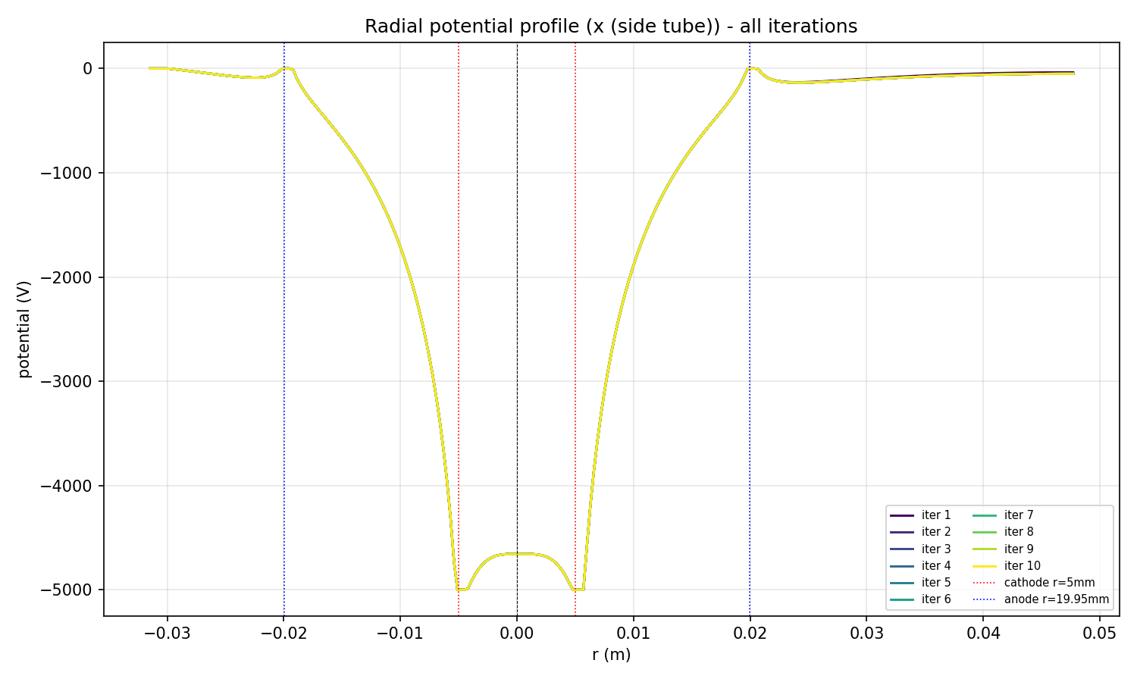
Radial potential along x (side tube), all iterations overlaid
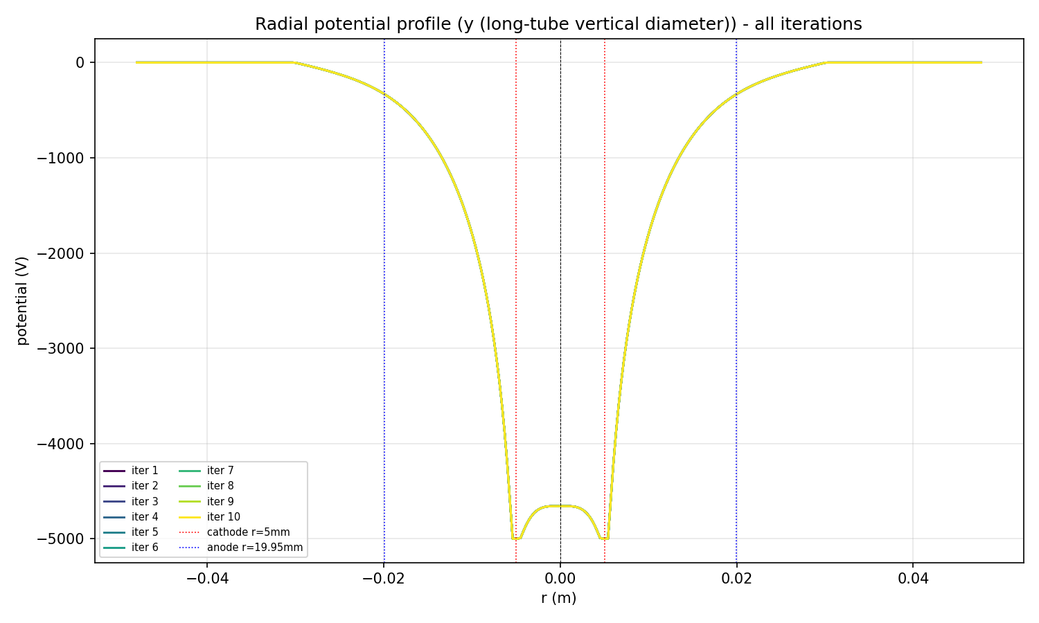
Radial potential along y (long-tube vertical diameter), all iterations overlaid
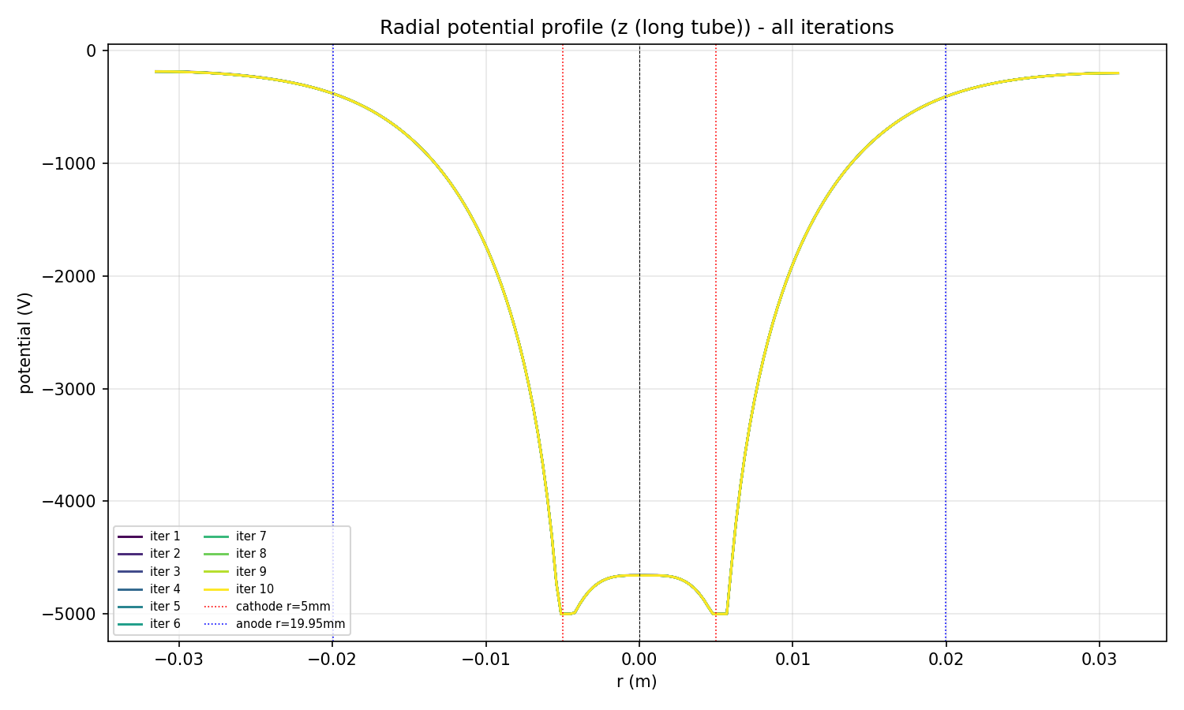
Radial potential along z (long tube), all iterations overlaid

Final Potential Field
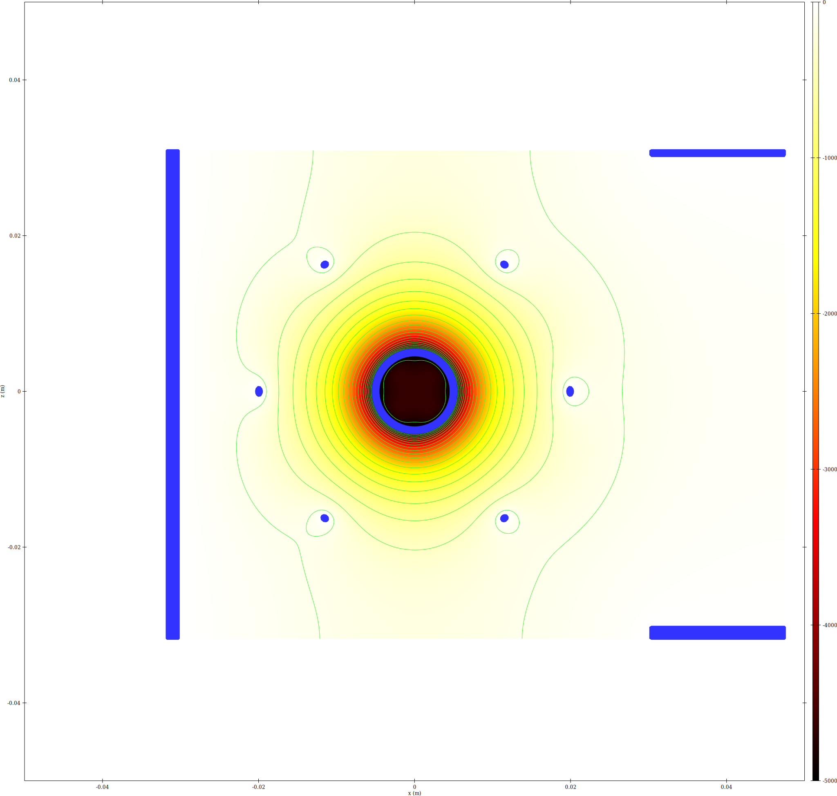
epot XZ slice
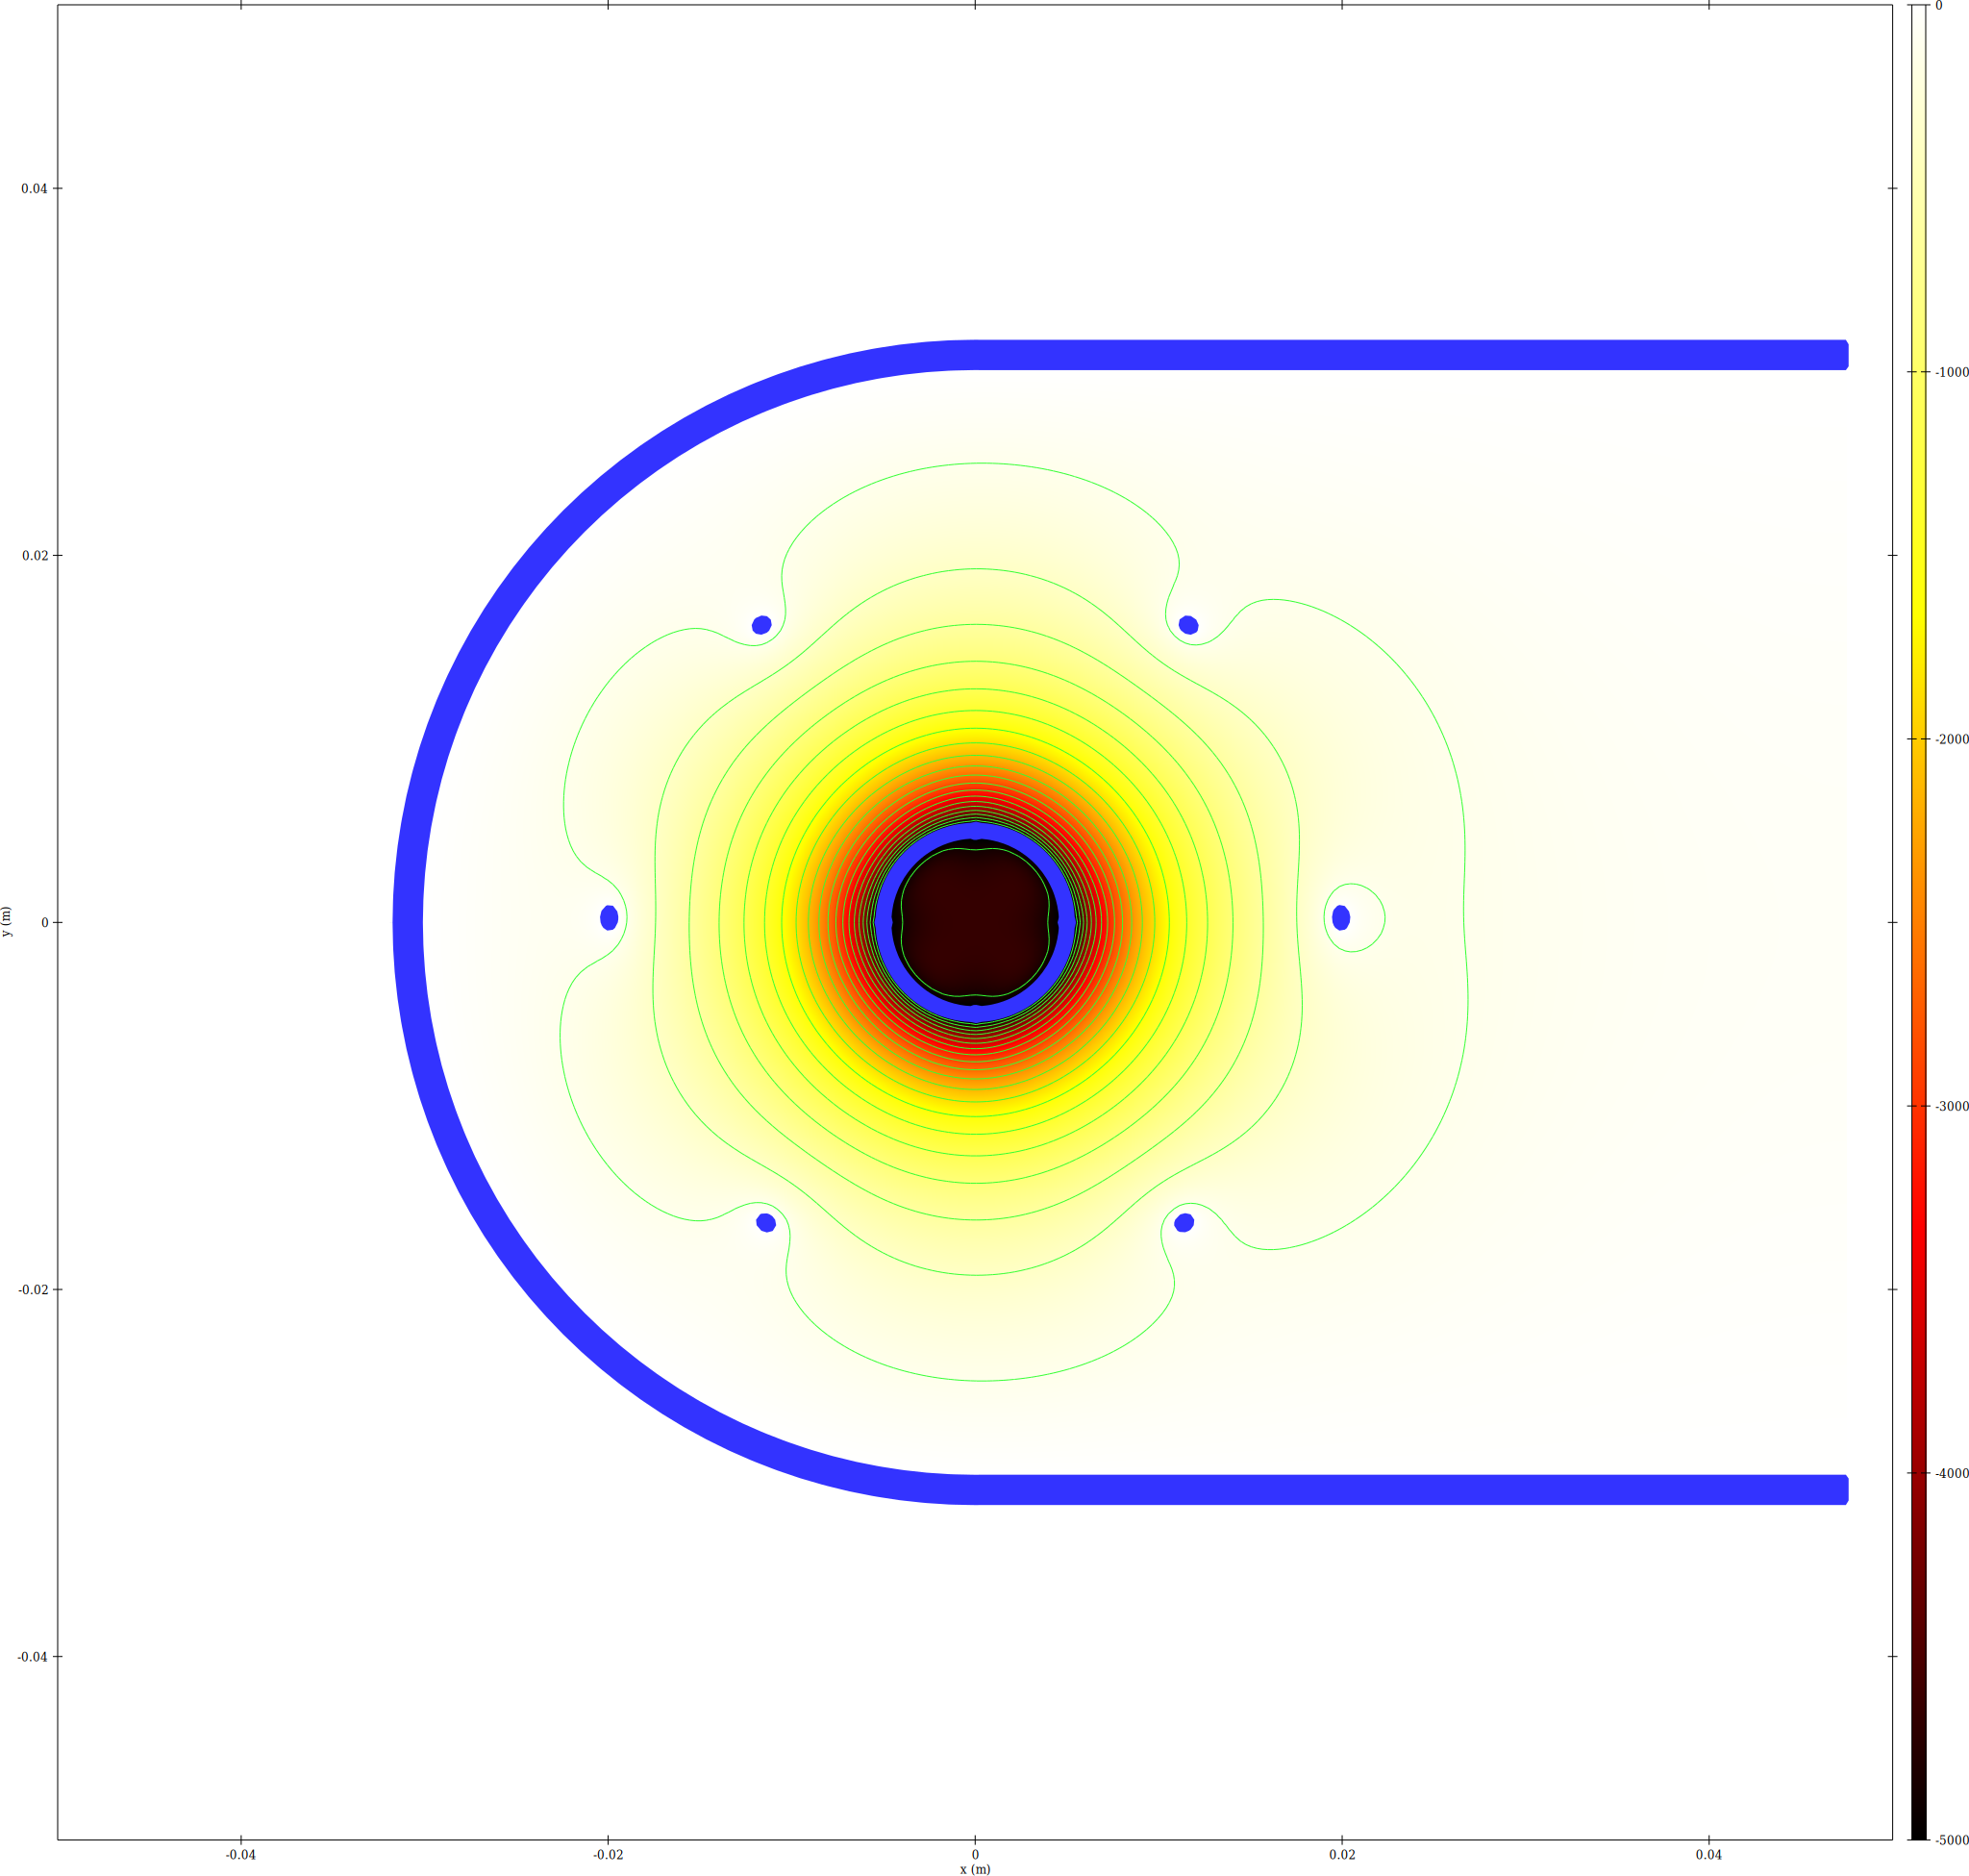
epot XY slice
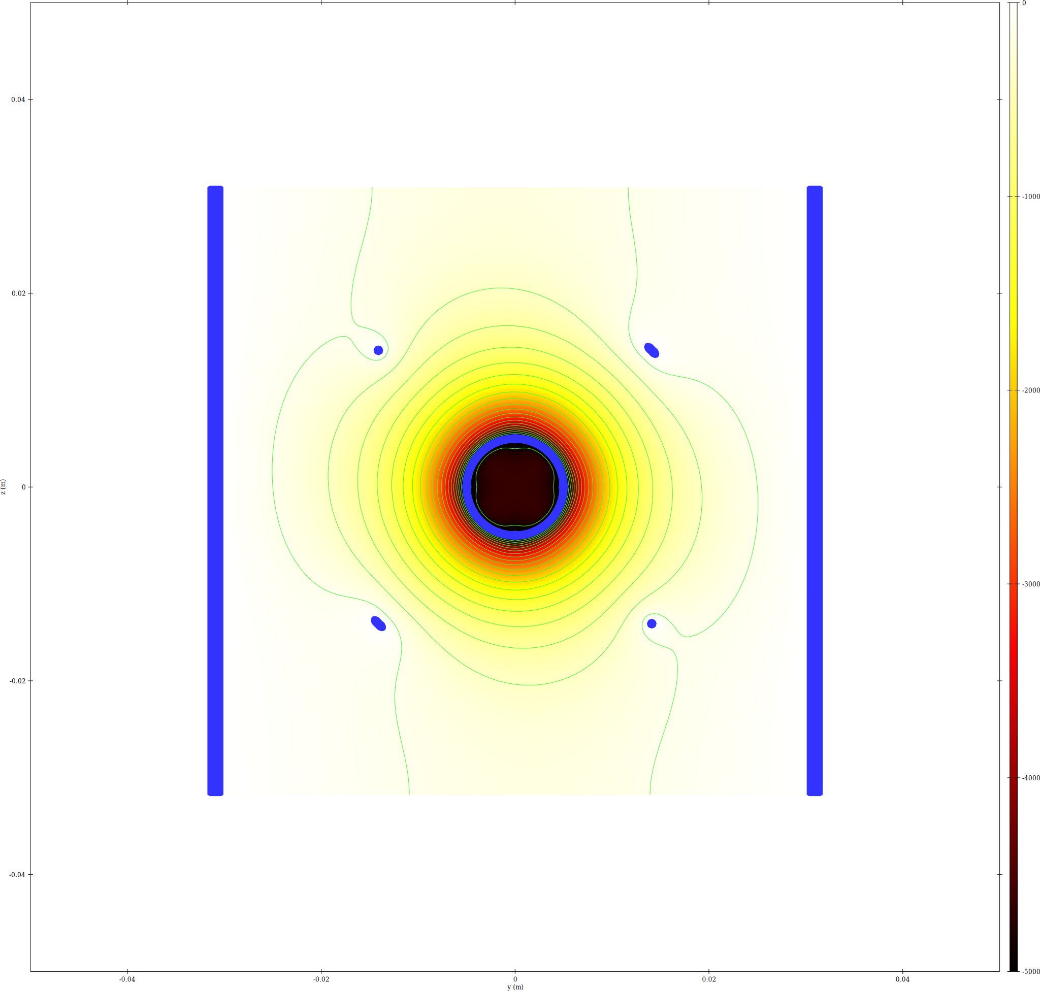
epot YZ slice at x=0

Trajectory Density
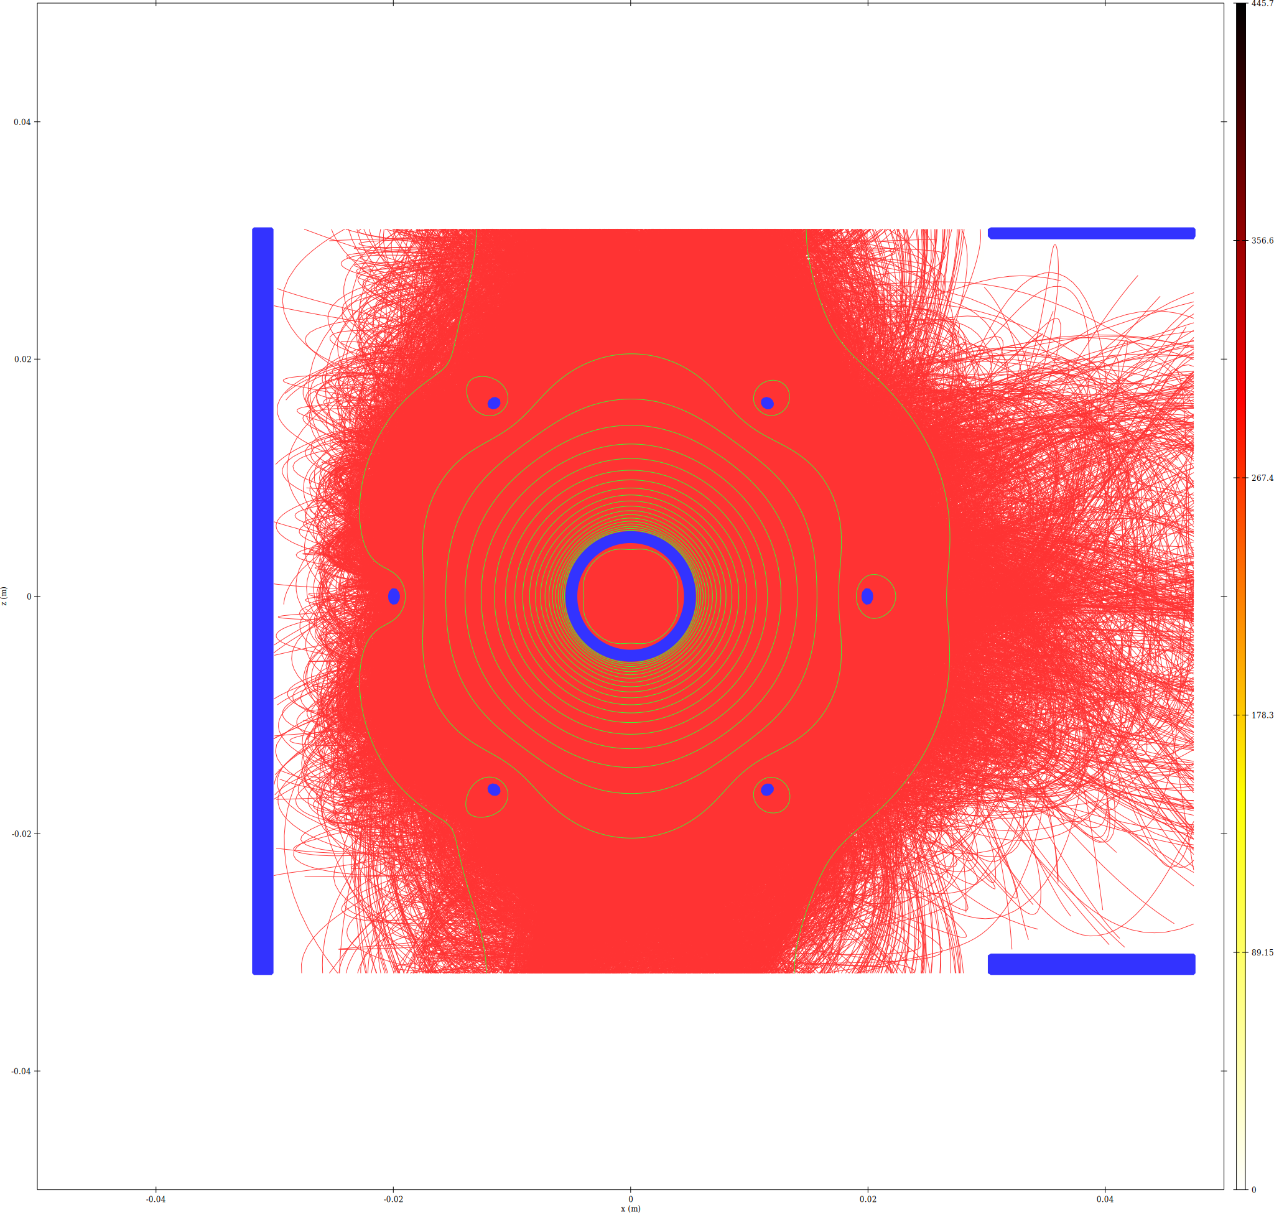
Trajectory density XZ slice
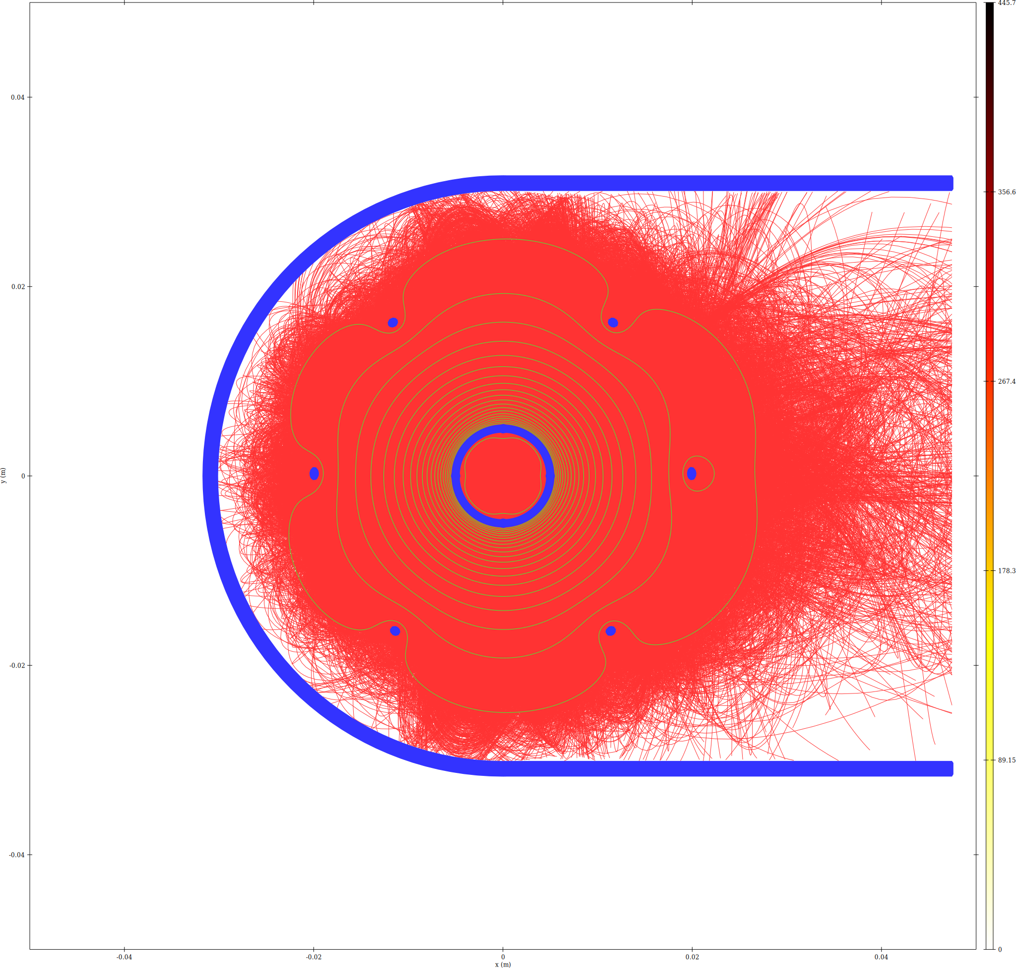
Trajectory density XY slice

Memory Estimate
Memory breakdown for run11/
N_clouds (ions) = 800000
N_clouds_e (electrons) = 800000
bytes/particle = 108, bytes/step = 56
Mesh nodes = 17808000 (4 scalar + 1 vector(3) fields)
Mesh-field memory = 0.929 GB
Solver workspace est. = 1.858 GB
Geometry est. = 0.066 GB
Constant overhead total = 2.853 GB
Particle data (constant) = 0.161 GB
iteration | ion_steps | e_steps | traj_MB | overhead_MB | total_GB
1 | 55561652 | 31124136 | 4629.52 | 3085.88 | 7.5346
2 | 55712470 | 31140039 | 4638.42 | 3085.88 | 7.5433
3 | 55529717 | 31153234 | 4629.37 | 3085.88 | 7.5344
4 | 55623433 | 31146706 | 4634.03 | 3085.88 | 7.5390
5 | 55583470 | 31131347 | 4631.07 | 3085.88 | 7.5361
6 | 55625835 | 31152742 | 4634.48 | 3085.88 | 7.5394
7 | 55632502 | 31140791 | 4634.19 | 3085.88 | 7.5391
8 | 55564530 | 31140114 | 4630.53 | 3085.88 | 7.5356
9 | 55566024 | 31156096 | 4631.46 | 3085.88 | 7.5365
10 | 55565497 | 31143144 | 4630.74 | 3085.88 | 7.5358

Convergence
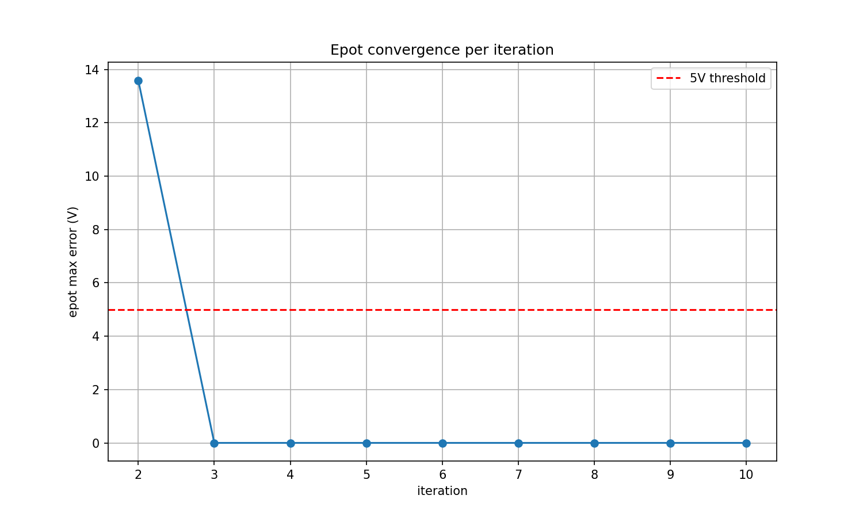
Epot max error vs iteration

